**PERANCANGAN PCB**

**ROBOT WELDING ARM MANIPULATOR 6-DOF**



Dirancang Oleh :

Alfonsus Giovanni Mahendra Putra / Teknik Listrik Industri / 40040621650042

**DEPARTEMEN TEKNOLOGI INDUSTRI**

**FAKULTAS SEKOLAH VOKASI**

**UNIVERSITAS DIPONEGORO**

**2024**

**PCB KONTROLER UTAMA**

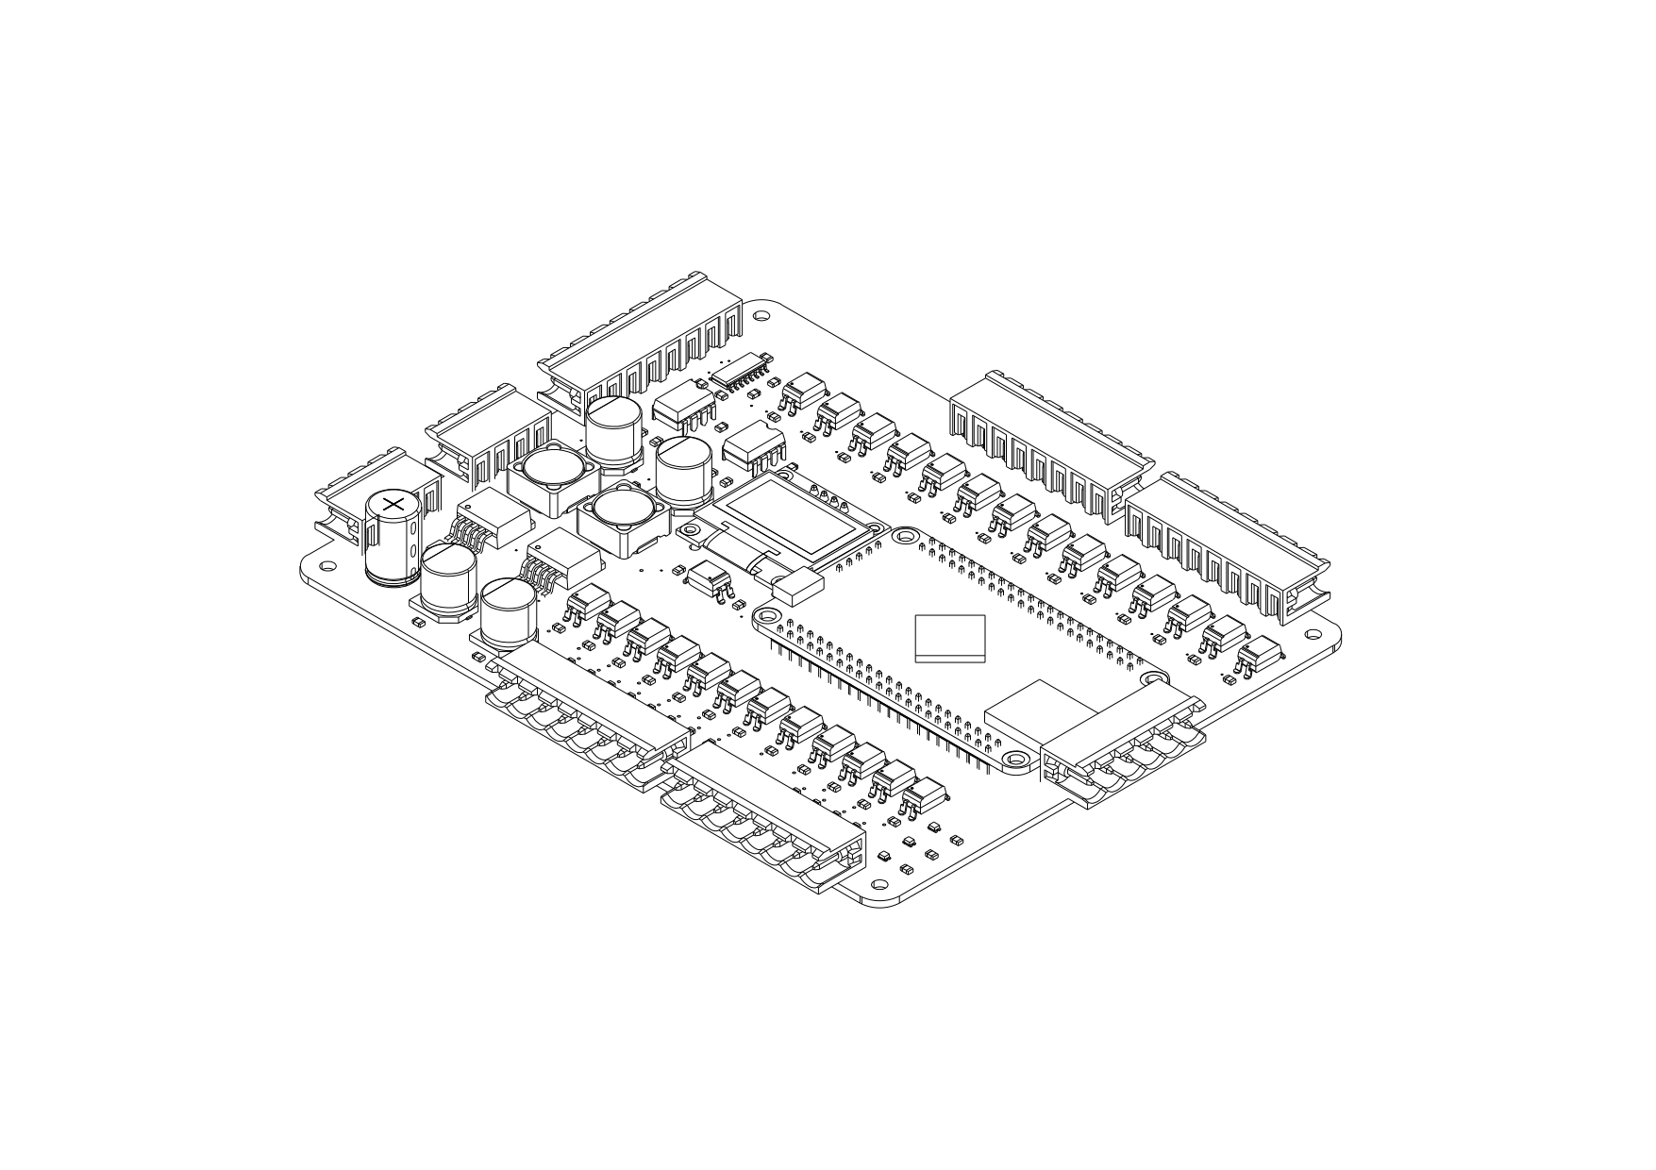

Spesifikasi:

1. Microcontroller STM32H743VIT6
2. 24VDC Supply
3. 5VDC and 3,3VDC Output
4. Dual Emergency Stop
5. 18 Channels Digital Input
6. 12 Channels Digital Output
7. RS-232 Communication
8. OLED LCD Interface

**SCHEMATIC DIAGRAM PCB KONTROLER UTAMA**

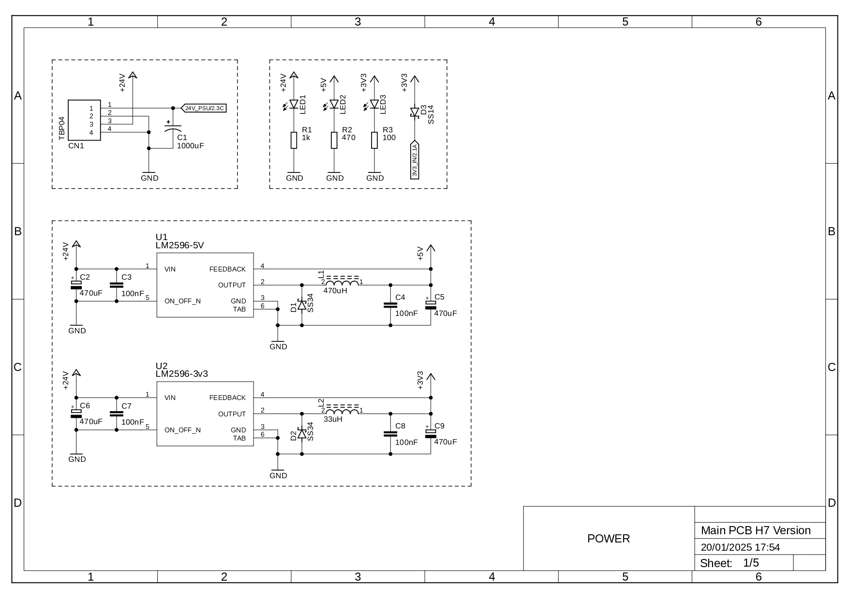

**SCHEMATIC DIAGRAM PCB KONTROLER UTAMA**

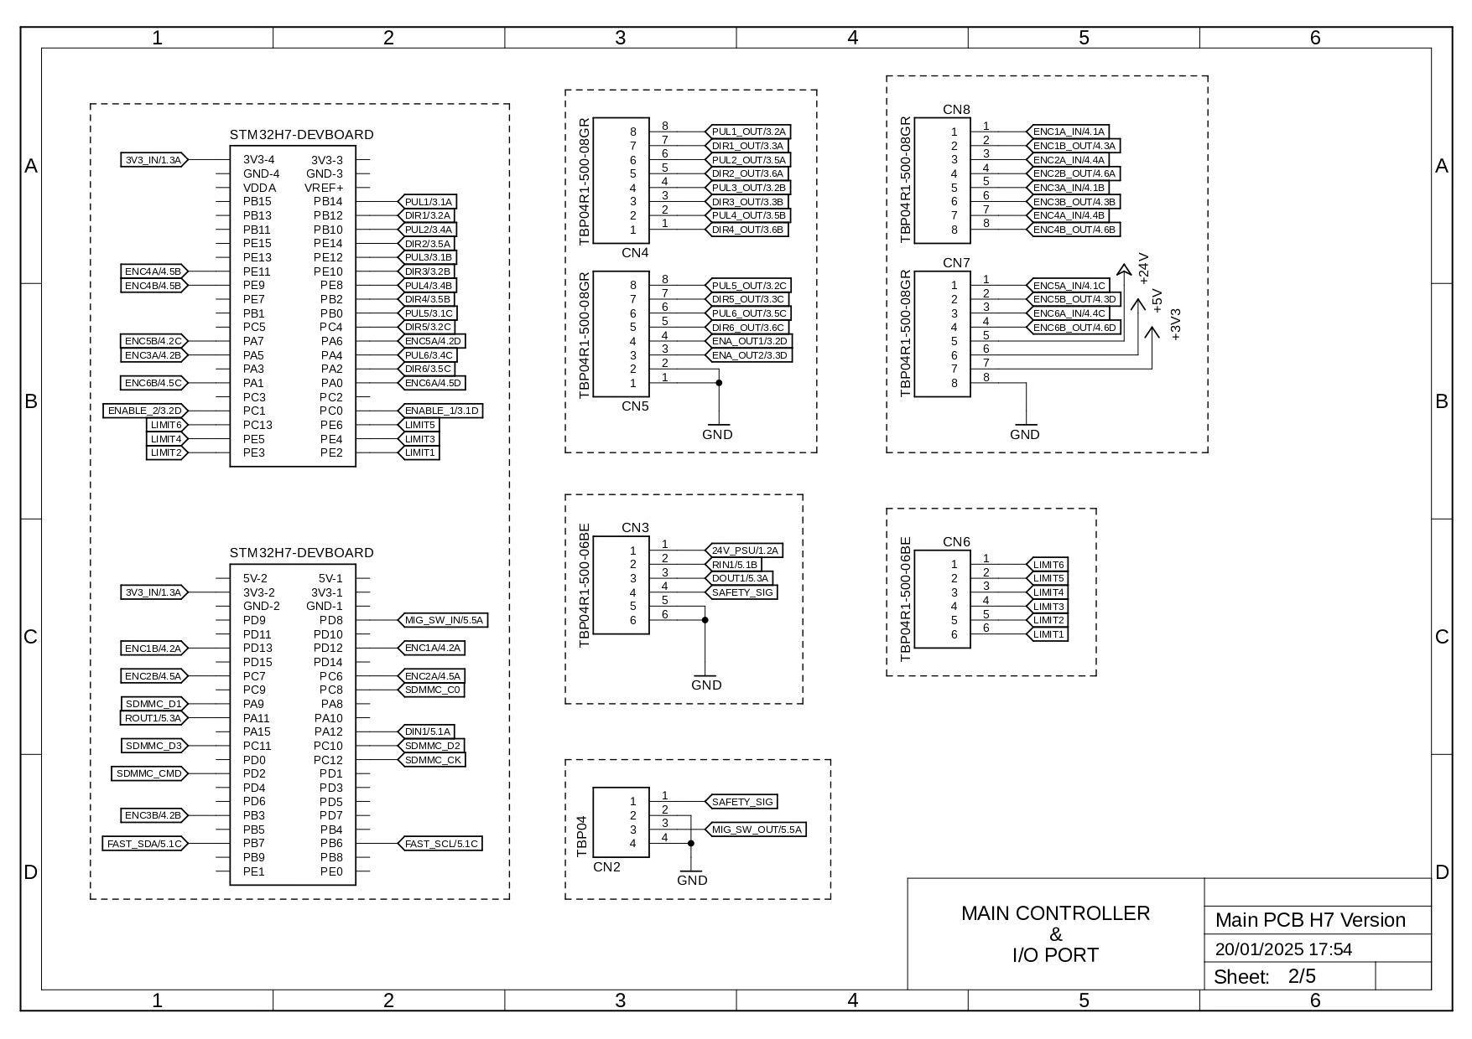

**SCHEMATIC DIAGRAM PCB KONTROLER UTAMA**

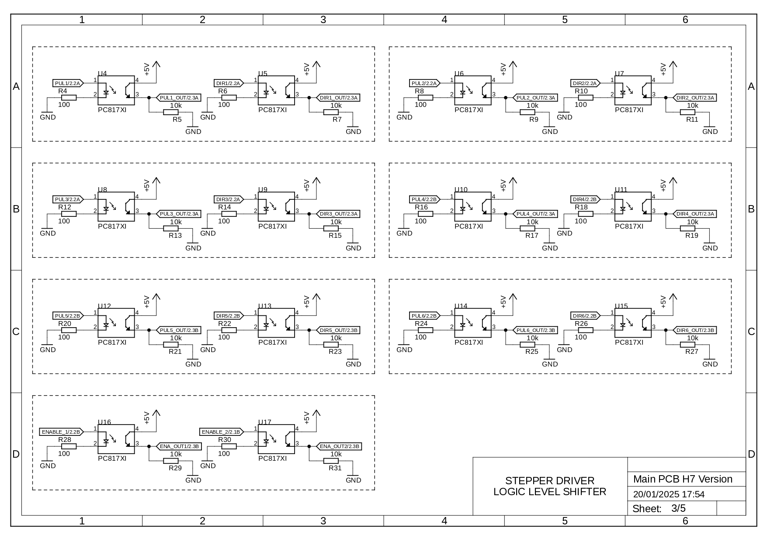

**SCHEMATIC DIAGRAM PCB KONTROLER UTAMA**

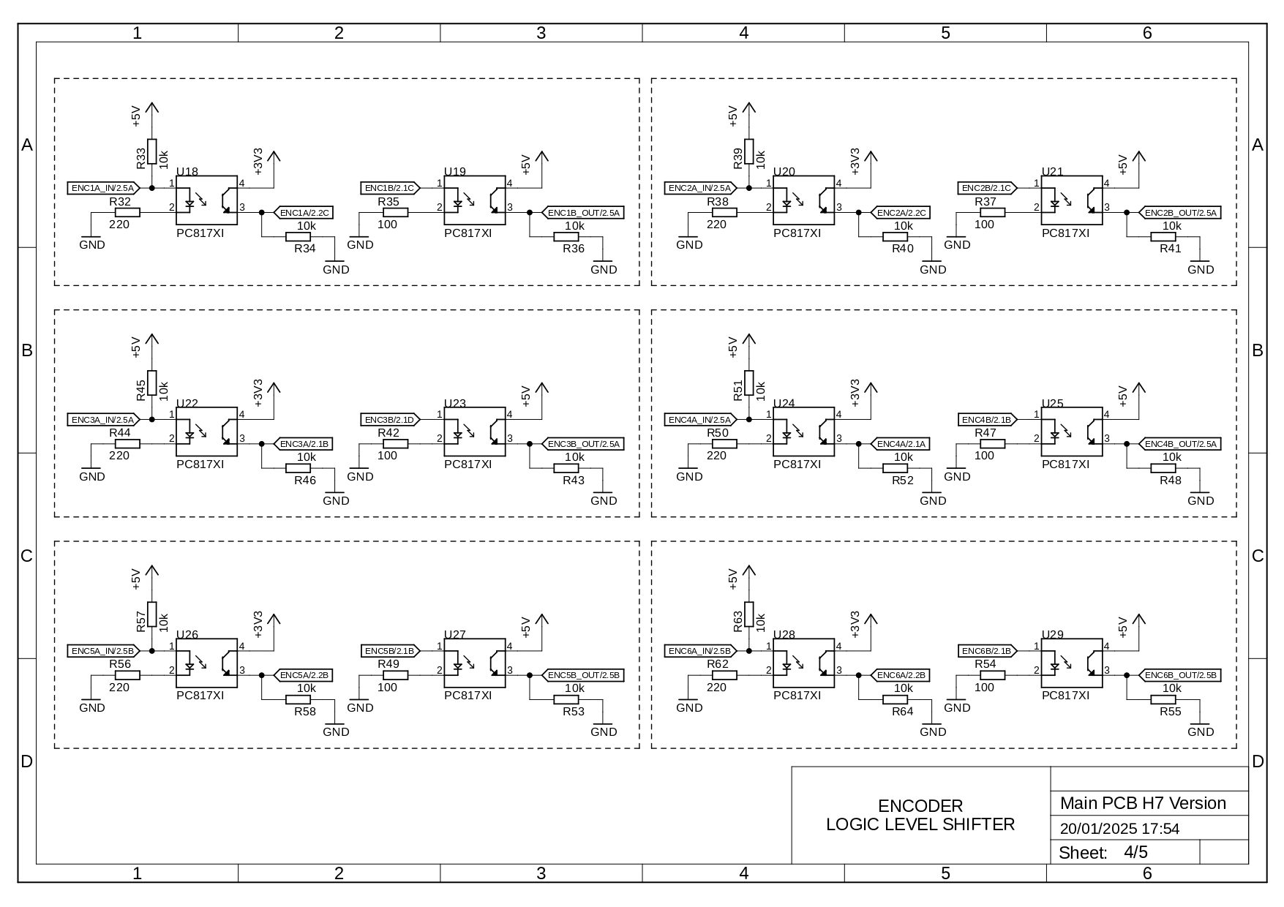

**SCHEMATIC DIAGRAM PCB KONTROLER UTAMA**

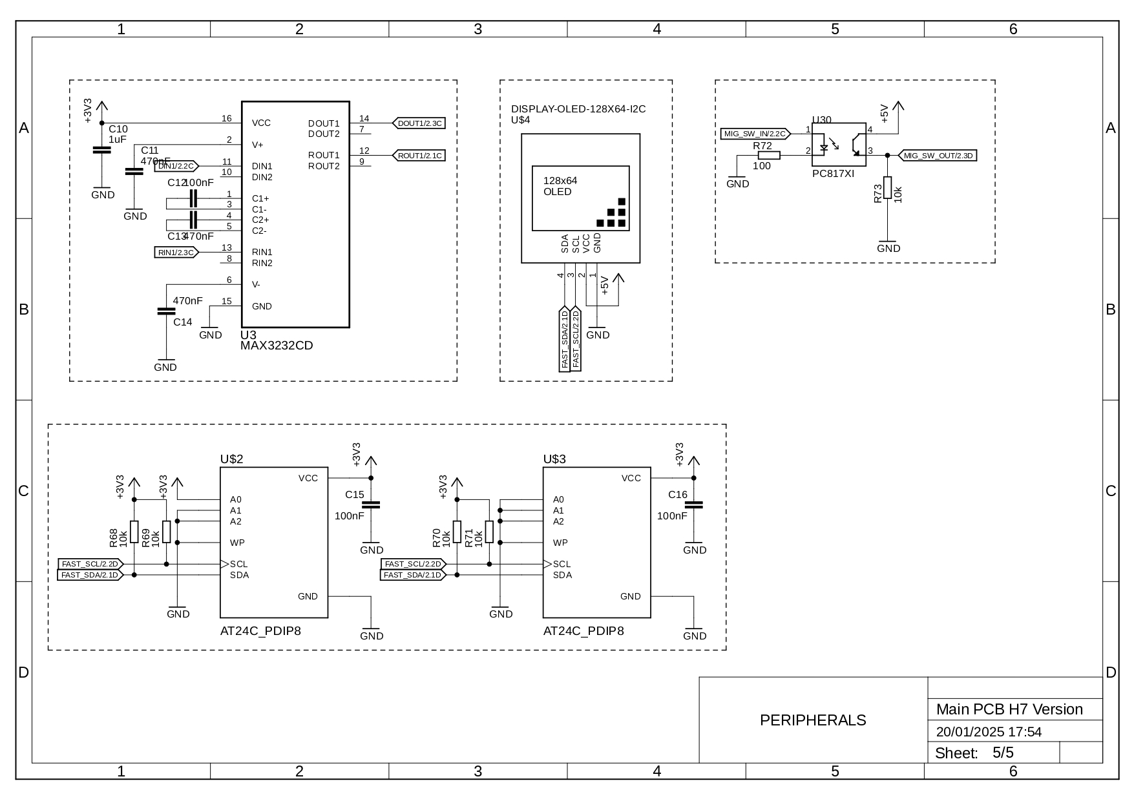

**PCB TEACH PENDANT**

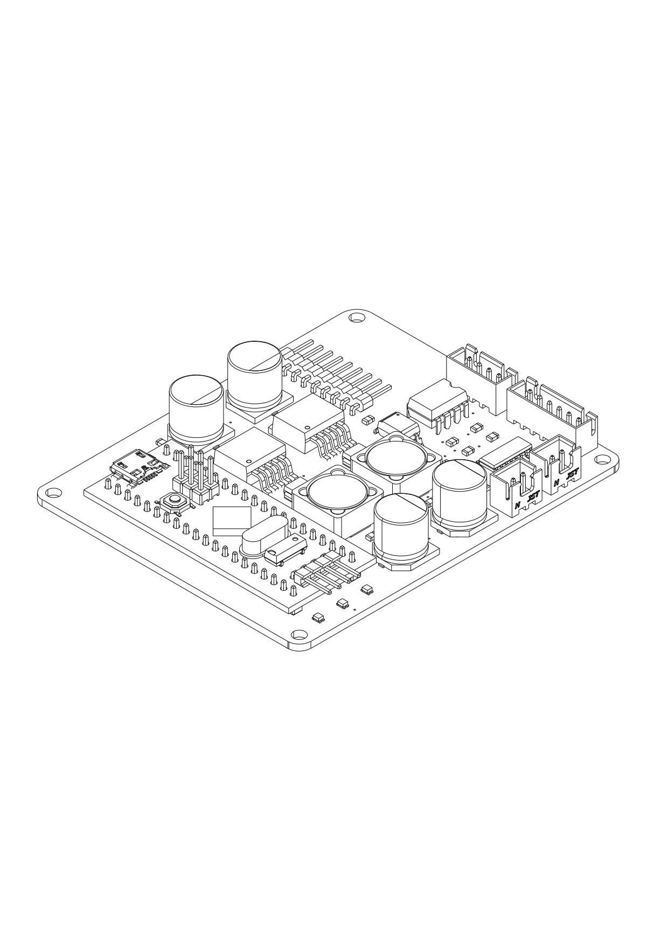

Spesifikasi:

1. Mikrokontroler STM32F103C8T6
2. 24VDC Supply
3. On/Off Selector Switch
4. Interface LCD 20x4
5. Keypad Matrix 5x4
6. Emergency Stop

**SCHEMATIC DIAGRAM PCB TEACH PENDANT**

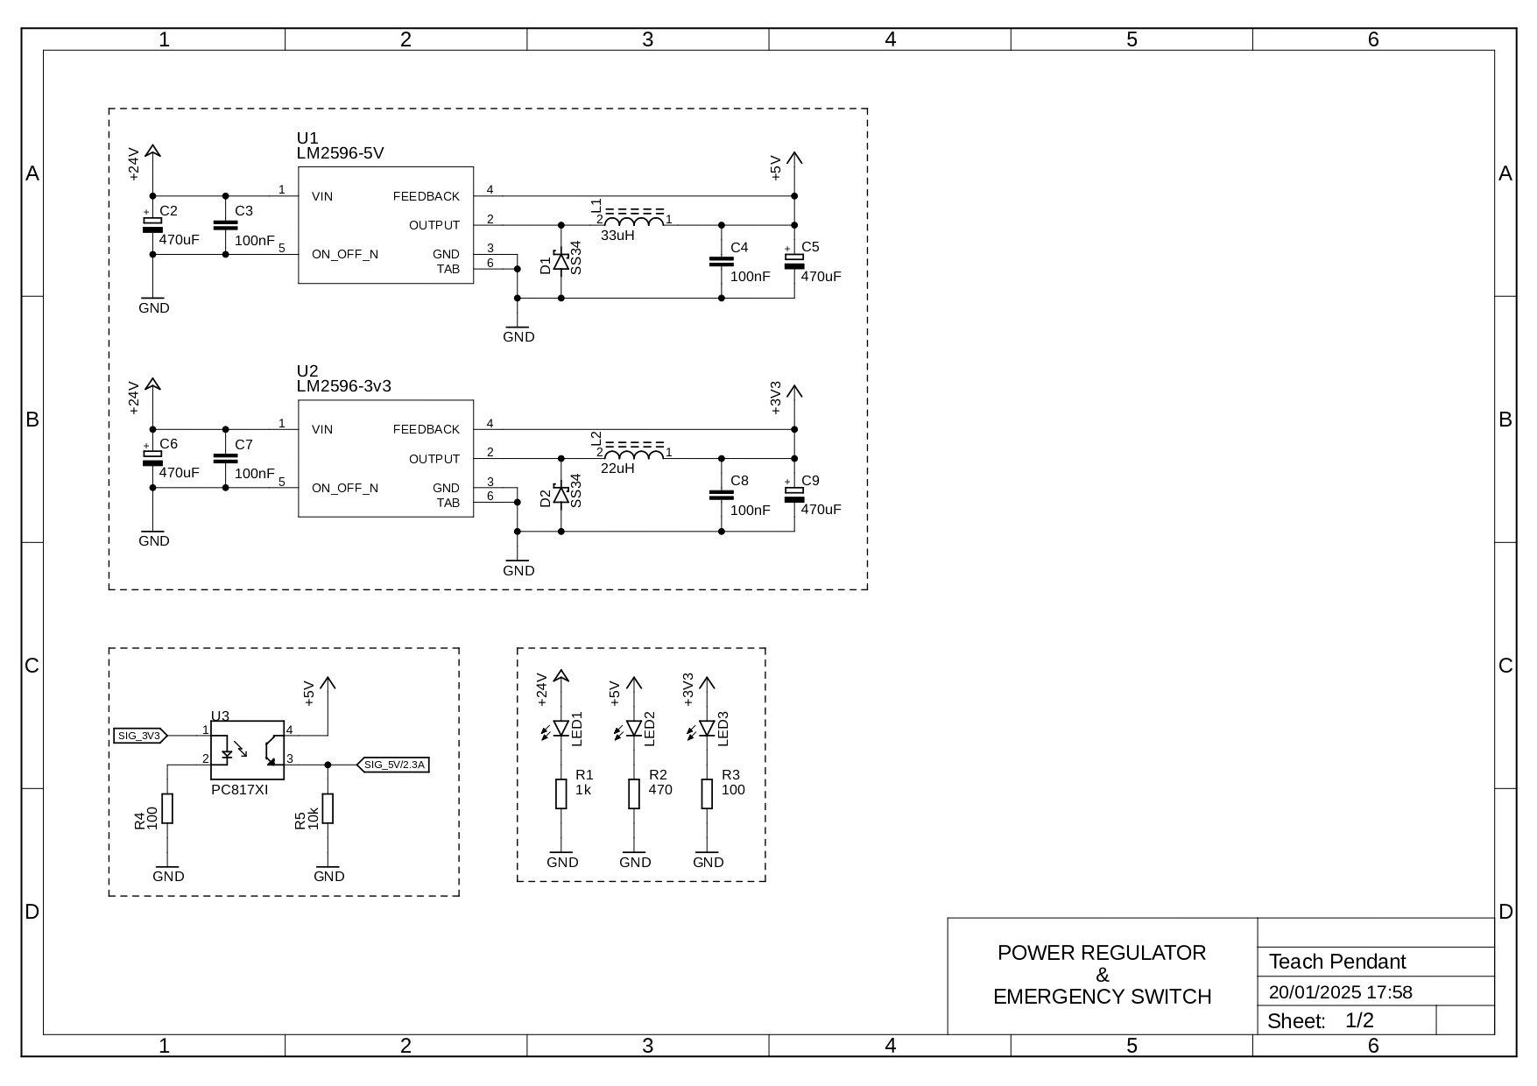

**SCHEMATIC DIAGRAM PCB TEACH PENDANT**

